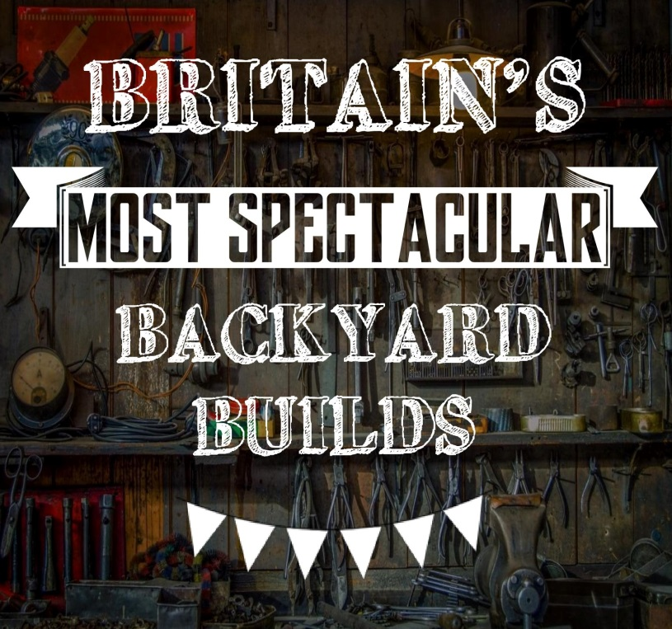

- Try to give as much relevant information as possible for each question
- Please email a selection of photos to support your application, of yourself as well as examples of your past and present work. So your application does not get blocked by our server, please email photographs in a separate second email to your application.
- If your application is successful, you will be telephoned by one of the production team for a further discussion.
- If you have not heard from us by Friday 18th December unfortunately your application has been unsuccessful.

Please email completed forms to: makers@rdftelevision.com
or post to:

Britain’s Most Spectacular Backyard Builds
RDF Television, Second Floor,
The Gloucester Building, Kensington Village,
Avonmore Road, London
W14 8RF

APPLICATION FORM
FULL NAME: (as on passport) |  |  |  | AGE
HOME ADDRESS:
YOUR CONTACT NUMBERS | YOUR EMAIL ADDRESS:
CITY OR TOWN ORIGINALLY FROM:
HOMELIFE - WHO DO YOU LIVE WITH?
FULL TIME OCCUPATION (job title & company name)
DESCRIPTION OF JOB
-Tell us about your job, where you work, what it entails, what’s interesting about it.
DO YOU HAVE ANY QUALIFICATIONS?
HOW WOULD YOUR FRIENDS AND FAMILY DESCRIBE YOU?
-What are their opinions about the things you create?
TELL US ABOUT YOUR LOVE OF MAKING / INVENTING / BUILDING?
-How long have you been doing it?
-How did you get into it?
-Why do you do it? What do you love about it?
WHAT HAVE YOU MADE IN THE PAST?
-Please provide as many examples as you’d like, and give details:
-Cost of making, duration of build, reason behind idea, it’s purpose once built
ARE YOU MAKING ANYTHING AT THE MOMENT?
-Is there something you have started but haven’t finished yet?
IF YOU COULD MAKE ONE THING, WITH UNLIMITED TIME & BUDGET, WHAT WOULD IT BE?
-Is there something you’ve always wanted to create, but never got around to doing it?
WHERE DO YOU WORK? (i.e. workshop / bedroom / shed?)
DO YOU WORK ALONE OR WITH FRIENDS / FAMILY / COLLEAGUES?
-Tell us about who helps you and their relationship to you
WHAT MATERIALS DO YOU USED / HAVE YOU USED?
-What are your main skills? E.g. glassblowing / woodwork
HAVE YOU HAD ANY TRAINING? Would you say you are amateur or professional?
HOBBIES & INTERESTS?
-What are your other passions?
DO YOU USE SOCIAL NETWORKS? Please provide details below
Facebook URL (i.e. www.facebook.com/jane.smith)
Twitter
Instagram
YouTube
Website
Other(s)

HOW DID YOU FIRST HEAR ABOUT APPLYING FOR THIS SHOW? (Please be specific, e.g. if it was a website please say which one or if it was an email please say who from)
AVAILABILITY
FILMING IS BETWEEN THE DATES OF:
4th JANUARY – 18th MARCH

You may be needed between 1 to 4 days in total

Please state if you are available between the above dates, and would be able to commit to between 1 to 4 days of filming (can include weekends)

If you know of any dates within this period that you won’t be available, please list these here.

WHAT ARE YOU NORMAL WORKING HOURS?
HAVE YOU PREVIOUSLY APPEARED ON A TV SHOW, AUDITIONED FOR OTHER SHOWS, OR DO YOU HAVE AN APPEARANCE ON A TV SHOW BROADCASTING IN THE FUTURE? (Please give dates & details)
DO YOU HAVE ANY MEDICAL CONDITIONS OR HEALTH ISSUES, WHETHER PHYSICAL OR PSYCHOLOGICAL, THAT THE PRODUCTION TEAM SHOULD BE MADE AWARE OF?
HAVE YOU EVER BEEN CONVICTED OF A CRIME OR ARE YOU THE SUBJECT OF ONGOING CRIMINAL PROCEEDINGS, OR DO YOU HAVE ANY COUNTY COURT JUDGEMENTS AGAINST YOU?

Skills:
For us to better understand where your skills lie, please provide details below
 | Beginner | Not bad | Good | Great
Welding
(give us examples of the type of welding you do)
 | Beginner | Not bad | Good | Great
Cutting
 | Beginner | Not bad | Good | Great
Sawing
 | Beginner | Not bad | Good | Great
Joining
 | Beginner | Not bad | Good | Great
Turning
 | Beginner | Not bad | Good | Great
General Mechanics
 | Beginner | Not bad | Good | Great
General Electrics
 | Beginner | Not bad | Good | Great
Familiarity with engines
 | Beginner | Not bad | Good | Great
Hydraulics
 | Beginner | Not bad | Good | Great
Water based
 | Beginner | Not bad | Good | Great
Air based
 | Beginner | Not bad | Good | Great
Other
(Please specify)

PLEASE EMAIL YOUR COMPLETED FORM, ALONG WITH PHOTOS TO:

makers@rdftelevision.com

IMPORTANT INFORMATION ABOUT THE USE OF YOUR DATA
- Personal information which you supply to RDF Television during the application, audition and casting process will only be used in association with the development, production and/or exploitation of the programme and your participation therein.
- Your personal information will be shared with members of the programme production team and relevant staff at the broadcaster of the programme and may be shared with our and the broadcaster’s insurers.
- RDF Television will ensure that any information provided for the purpose of producing the programme will be used in accordance with the Data Protection Act 1998.
- By submitting this application, you agree to RDF Television Limited and its group companies contacting you and keeping you informed about future productions that may be of interest to you. You'll be able to opt out at any time.
- All information will be kept secure and treated as confidential. In submitting this application form you are consenting to us using your personal information as set out in this section.

