South-West Edinburgh Basketball Club - Logo Competition
Attention all young people in South-West Edinburgh. You have the amazing opportunity to design the official logo for the South-West Edinburgh Basketball Club.
The closing date for entries is Thursday 4th February 2016.
Logo Requirements
The only requirement for the logo is for it to include one of the following names (it is up to the entrants which name to use depending on which one fits better with their design):

- Sharks Basketball
- Edinburgh Sharks
- Edinburgh Sharks Basketball Club

See below the logos of other clubs with sharks in their name to give you some ideas of what exists:

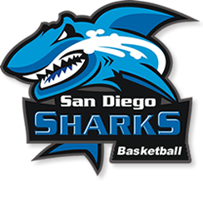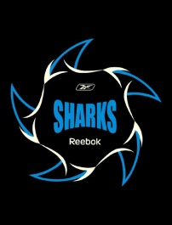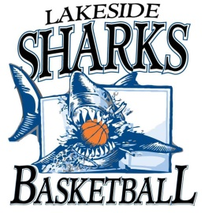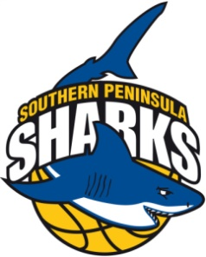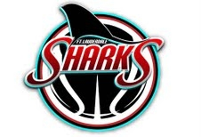
The club also has three sub-sections with the following logos:

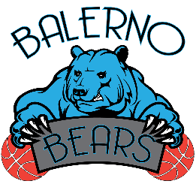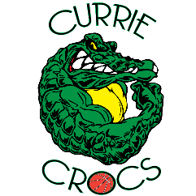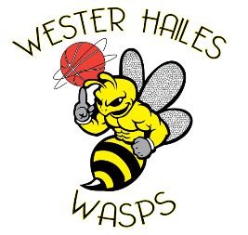
Competition Details
Target audience | The competition is targeted at children and young people at Primary and Secondary Schools in the following school clusters: Balerno, Currie and Wester Hailes.
Timeline | The logo competition went live as of Thursday 14th January 2016.  All entries are to be in by Thursday 4th February 2016.  The winning logo will be announced on Friday 5th February 2016.
Prize | Individual Class/ School  Basketball Scotland Signed Kieron Achara basketball  SWEBC Free basketball top  Heriot-Watt Full hall for 2 sessions of Basketball Coaching (2 hours per/session) for your class at Heriot-Watt or your either school.
Entries | Electronic entries are to be sent to Steve Archer on headbasketballcoach@hw.ac.uk  Paper entries are to be sent to following address:  Steve Archer, Heriot-Watt University Sports Union, Heriot-Watt University, Edinburgh, Scotland, EH14 4AS
Please input logo here (and include full name, school and class):
Name: ____________________

School : ___________________

Class: _____________________

